Feature Scaling?

Feature Scaling is a technique to standardize the independent features present in the data in a fixed range.

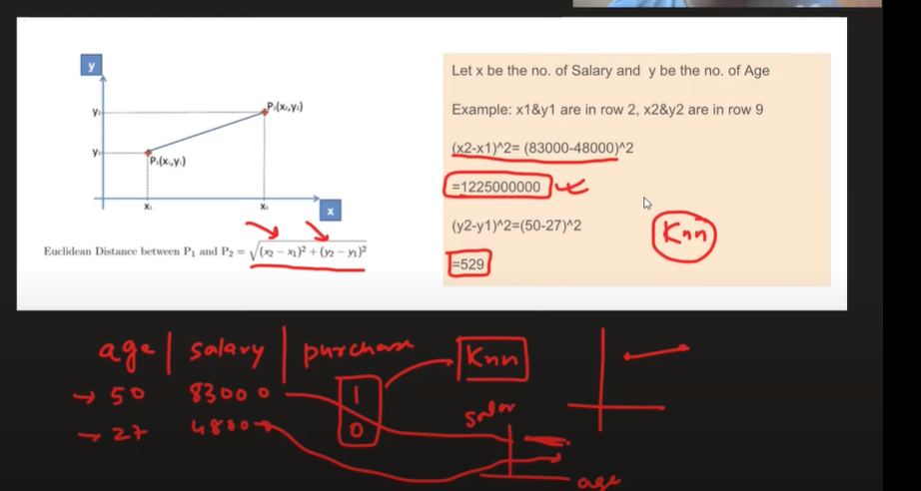

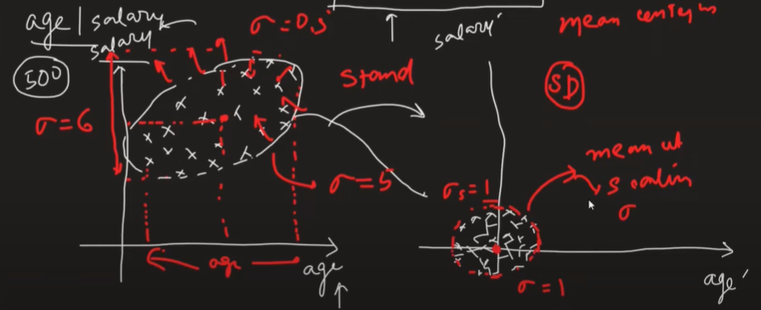

When to use Standardization  
